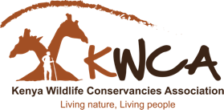
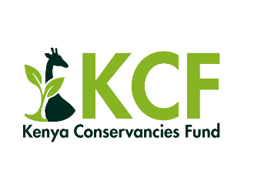
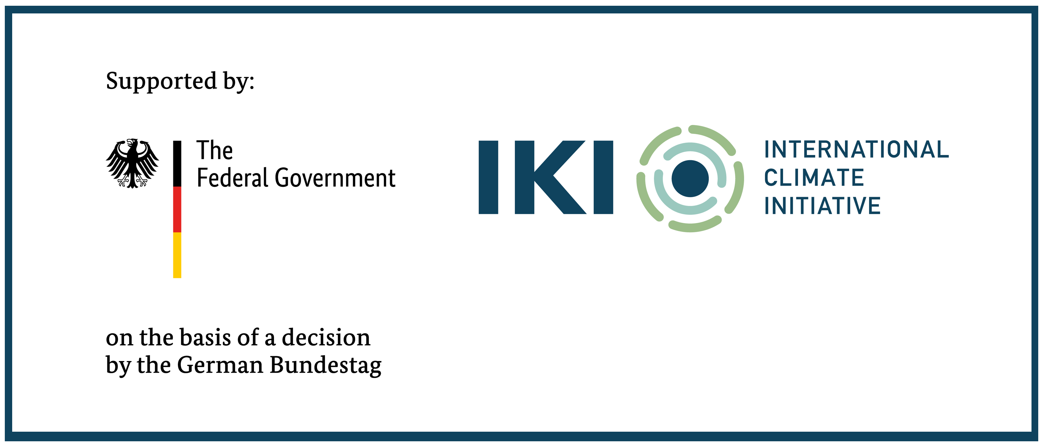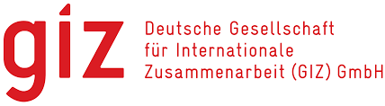

CALL FOR CONCEPTS 2025: PROJECT PROFILE QUESTIONNAIRE

Fill the form appropriately (Maximum words:100 each section)

Part I: Basic Information
1.0 Conservancy Information

I. | Full Name of the Conservancy (As per Reg. certificate)
II. | Contact Address
III. | County
IV. | Size of Conservancy in hectares
V. | Website
VI. | Year established
VII. | Contacts Persons | Chairperson…………………………… Email………………… Tel…………….…
 |  | Manager………………………………… Email………………… Tel…………….…
 |  | Accountant…………………………… Email………………… Tel…………….…
1.1 Legal Registration & Affiliation
I. | How is the conservancy registered (Trust, Company, Association, etc) (Submit copy of certificate)
II. | Is the conservancy registered by KWS, when?

III. | Describe the land ownership  arrangement of the Conservancy
IV. | Is the conservancy a member of KWCA, Yes/No
V. | Has the conservancy paid membership fees each year?
1.2 Governance
I. | Briefly describe your governance? What is your current board size? Indicate the number of male and female members
II. | How often does the board meet, how do you rate board effectivesness?
III. | Do you conduct AGMs, when was the last one held?
1.3 Management
I. | How many staff work full time in the conservancy, how many are male/ female?
II. | How many casual workers work in the conservancy? How many male/female?
III. | Which policies has the conservancy adopted to guide internal operations?

IV. | Which accounting system/software is used in the management  of conservancy  finances?
V. | Is the conservancy expenditures audited annualy (Share the most recent audit report)

2.0 Conservancy Achievements
I. | What is the overall goal/purpose of the conservancy?
II. | Describe briefly the ecological significance of the  area managed by the conservancy? e.g., habitat, corridor, water source, species)
III. | Describe how the landowners/ communities are  effectively engaged in the conservancy activities? (Attach meeting minutes or reports e.g FPIC report)
IV. | How is the conservancy working to include women and youth in decision making and participation on conservancy activities?

V. | In summary outline 5 key achievements the conservancy has attained in the last 5 years?

Part II: Project Information
3.0 Project Description: This section is meant to outline in a concise way the proposed priority actions that the conservancy intends to implement in its journey to self sufficiency, investment readiness and maturity

I. | Project Title
II. | What challenges is the conservancy facing that the project intends to address
III. | Summary of conservancy activities prioritized to be implemented
IV. | What timeline in months will the activities be implemented (Maximum for IKI funding is 18 months)
V. | Budget: How much will it cost to implement the activities identified?
VI. | What changes will the conservancy realise by implementing these activities?
VII. | Who are the main beneficiaries of the project (give numbers if available)

4.0 Additional Information

Please provide any additional information relevant to the idea described in the sections above (Maximum 100 words)

